2015 Nation’s Report Card Eighth Grade Mathematics
Fahima Bacha
New Jersey City University
Spring 2017

Introduction
The National Assessment of Educational Progress (NAEP) periodically produces the Nation’s Report Card on American students’ performance and academic achievement in K-12 in various subjects including mathematics, science, writing, reading and U.S. history. NAEP is sponsored by the U.S. Department of Education and its goal is to provide information to the schools, the public and the media about the progress of education in the United States (NAEP,2015). According to the 2015’s Nation’s Report Card, eighth grade mathematics scores in 2015 have decreased in twenty-two states compared to the 2013’s scores, the same scores in thirty states have not shown a significant improvement, and only one state has higher score than it did in 2013. In addition, the results of the 2015 Programme for International Student Assessment (PISA) mathematics raised concerns about the United States’ educational system global competitiveness as American fifteen-year-old students ranked below the Organization for Economic Co-operation and Development’s (OECD) average and were advanced by countries such China, Japan, Germany, Russia and France (Kiersz,2016; Pisa,2017).
This paper will include the analysis of the data on students’ performance in the 2015 NAEP mathematics assessment by ethnicity and will investigate the existence of statistical differences in average scores using a Paired Samples t-Test. The analysis will be based on the interpretation of the results from both descriptive and inferential statistics as well as from graphs and bars. The results of this analysis will provide information that will help the United States Department of Education improve students’ performance and close the achievement gap between ethnicities. The U.S. Department of Education revealed that the gap in achievement in mathematics between ethnicities is persistent and the use of strategies to narrow this gap is crucial ( Brown,2012; Hemphill & Vanneman, 2011).

The Data Set
This statistical analysis will be conducted on data retrieved from the 2015 Nation’s Report Card Mathematics Assessment in eighth grade. The data set was downloaded from: https://www.nationsreportcard.gov/reading_math_2015/#mathematics/state?grade=4
The 2015 Mathematics Grade Eight Assessment Report Card file contains average scale scores in mathematics per state in public and nonpublic schools as well as percent of students in various achievement levels organized by ethnicity. This dataset includes states’ performance based on average scale scores on the 2015 NAEP mathematics assessment for U.S. states and jurisdictions (N= 51) for the following ethnicities: White, Black and Hispanic. There were missing values for Black and Hispanic ethnicities in some states. Black ethnicity scores were missing for Hawaii, Idaho, Maine, New Mexico, South Dakota, Utah, Vermont and Wyoming and Hispanic ethnicity scores were missing in Maine, Vermont and West Virginia.
The variables
This data set contains fifteen variables, two are categorical variables which are State and Ethnicity and twelve are quantitative variables. The Variables are:
State/ Jurisdiction: this variable holds the name of state /jurisdiction
White Average scale score: this variable refers to the average scale score of students belonging to white ethnicity.
Percent White Below Basic: this variable stores the percent of White students performing below basic level.
Percent White At or above Basic: this variable stores the percent of White students performing at or above the basic level.
Percent White At or Above Proficient: this variable stores the percent of White students performing at or above proficiency level.
Percent White At Advance: this variable stores the percent of White students performing at the advanced level.
Black Average Scale Score: this variable refers to the average scale score of students belonging to Black ethnicity.
Percent Black Below Basic: this variable refers to the percent of Black students performing below basic level.
Percent Black At or above Basic: this variable refers to the percent of Black students performing at or above the basic level.
Percent Black At or Above Proficient: this variable stores the percent of Black students performing at or above proficiency level.
Percent Black At Advance: this variable stores the percent of Black students performing at the advanced level.
Hispanic Average Scale Score: this variable refers to the average scale score of students belonging to Hispanic ethnicity.
Percent Hispanic Below Basic: this variable refers to the percent of Hispanic students performing below basic level.
Percent Hispanic At or above Basic: this variable refers to the percent of Hispanic students performing at or above the basic level.
Percent Hispanic At or Above Proficient: this variable refers to the percent of Hispanic students performing at or above proficiency level.
Percent Hispanic At Advance: this variable refers to the percent of Hispanic students performing at the advanced level.
Descriptive Statistics
This statistical analysis will begin by examining the differences in scores between the three ethnicities. The descriptive statistics table below (Table 1) presents the variables considered for analysis in this project. The table shows that White average scale score is higher, followed by Hispanic then Black average scale score in mathematics. White-Average scale score of eighth grade White students was (N=54, M=290.87,SE=6.99), Hispanic-Average scale score was (N=51, M=270.05,SE=4.93) and Black-Average scale was (N=43, M=259.49,SE=5.51).

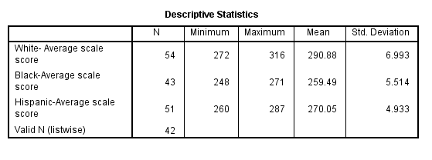
Table1: Descriptive Statistics on Average Scale Score by Ethnicity.
The histogram below indicates that White-Average Scale Score was greater across all states/jurisdiction (Table 2) than Hispanic-Average Scale Score and Black-Average Scale Score which indicates discrepancies in performance between ethnicities in U.S. states.
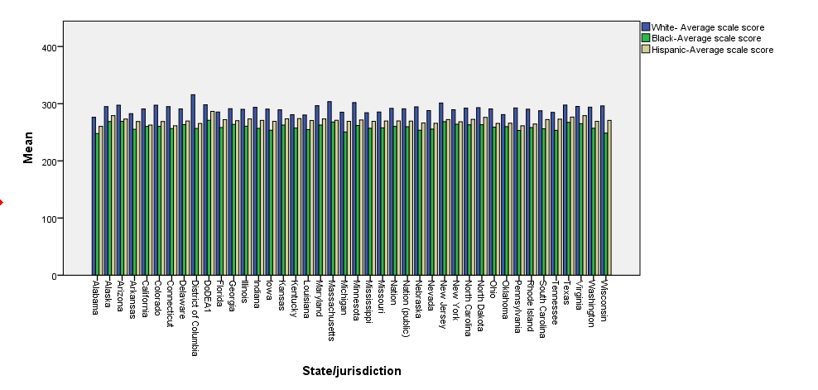
Table2: Histogram of the Average Scale Score by Ethnicity and States.
Furthermore, the Side-by-Side boxplot (Table 3) and the frequencies table (Table 4) show the difference in scores and clearly indicates gaps in average scores between ethnicities as well as the presence of outliers. White Average Scale Score (N=54, M=290.87) with one 1 missing value, Black Average Scale Score(N=43 , M=259.49 ) with 12 missing values and Hispanic Average Scale Score(N=52, M=270.05) with 4 missing values. These gaps in Average Scale Score were also shown in the interquartile range(IQR) as White Average Scale Score IQR = 8.4, Hispanic Average Scale Score IQR= 7.21 and Black Average Scale Score IQR=6.59.
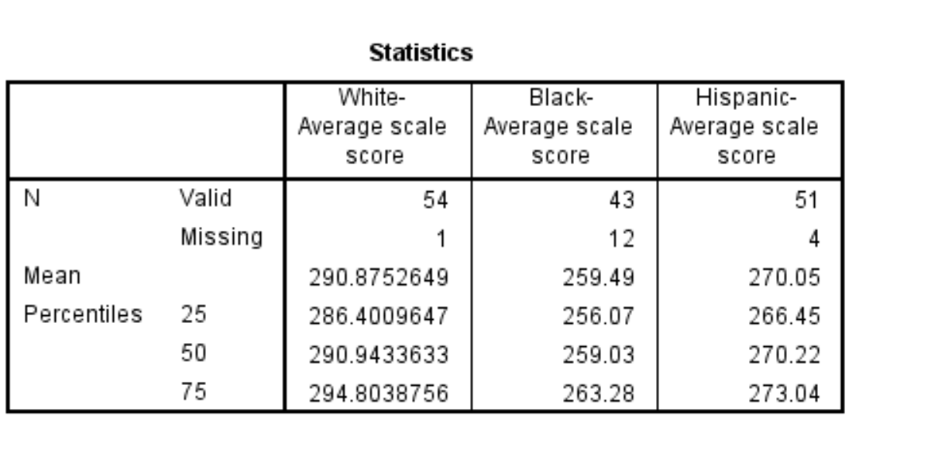
Table 3: Frequencies Table.
Extremes outliers were identified for White Average Scale Score in the District of Columbia and for Hispanic Average Scale Score in the Department of Defense Education Activity(DoDEA). These extreme values are above the third quartile which indicate good performance. Minimum values were also found in Hispanic Average Scale Score in Pennsylvania, Connecticut and Alabama. These outliers were below the first Quartile which indicates low performance in those states (Table 4).
. 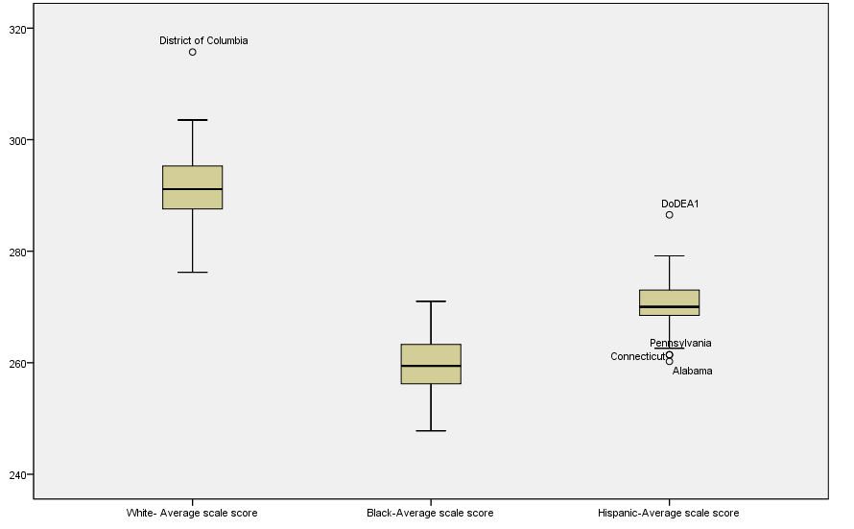
Table 4: Boxplot of Average Scale Scores by Ethnicity

Inferential Statistics
A Paired Sample t-Test was run on the variables White Average Scale Score, Black Average Scale Score to find if the differences between the means are significant. Assumptions of randomness of the sample and normal distribution of difference in scores were examined and an alpha level of 0.01 (α=0.01) will be used to test for significance.
The hypothesis: There is a significant difference in average scale scores between ethnicities in the mathematics NAEP assessment.
The Null Hypothesis: There isn’t a significant difference in average scale scores between ethnicities in the mathematics NAEP assessment.
SPSS was used to run the Paired Samples t- Test and the tables below were generated.
The results of the Paired Samples Statistics table (Table 5) below show that the White Average Scale Score (M=291.18, SE=7.68) is higher than Hispanic Average Scale Score(M=270.30, SE=5.03) and Black Average Scale Score(M=259.57,SE=5.55).

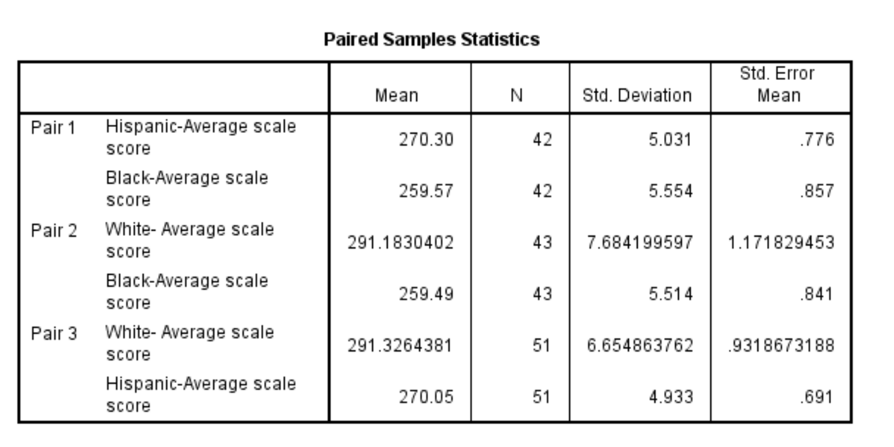
Table 5: Paired Samples Statistics.
In addition, the Paired Samples t-Test (Table 6) for Pair 1 which compares Hispanic Average Scale Score and Black Average Scale Score is t(41)= 14.920 and p-value<0.01. Pair 2 t-Test results that compare the means of White Average Scale Score and Black Average Scale Score show that t(42)=29.164 and p-value < 0.01. Pair 3 compares the means of White Average Scale Score and Hispanic Average Scale Score t(50)=20.392 and p-value < 0.01. Based on these results, it safe to reject the null hypothesis and conclude that the difference between the means of the average scale scores among the three Ethnicities White, Black and Hispanics in the 2015 NAEP math assessment is significant.

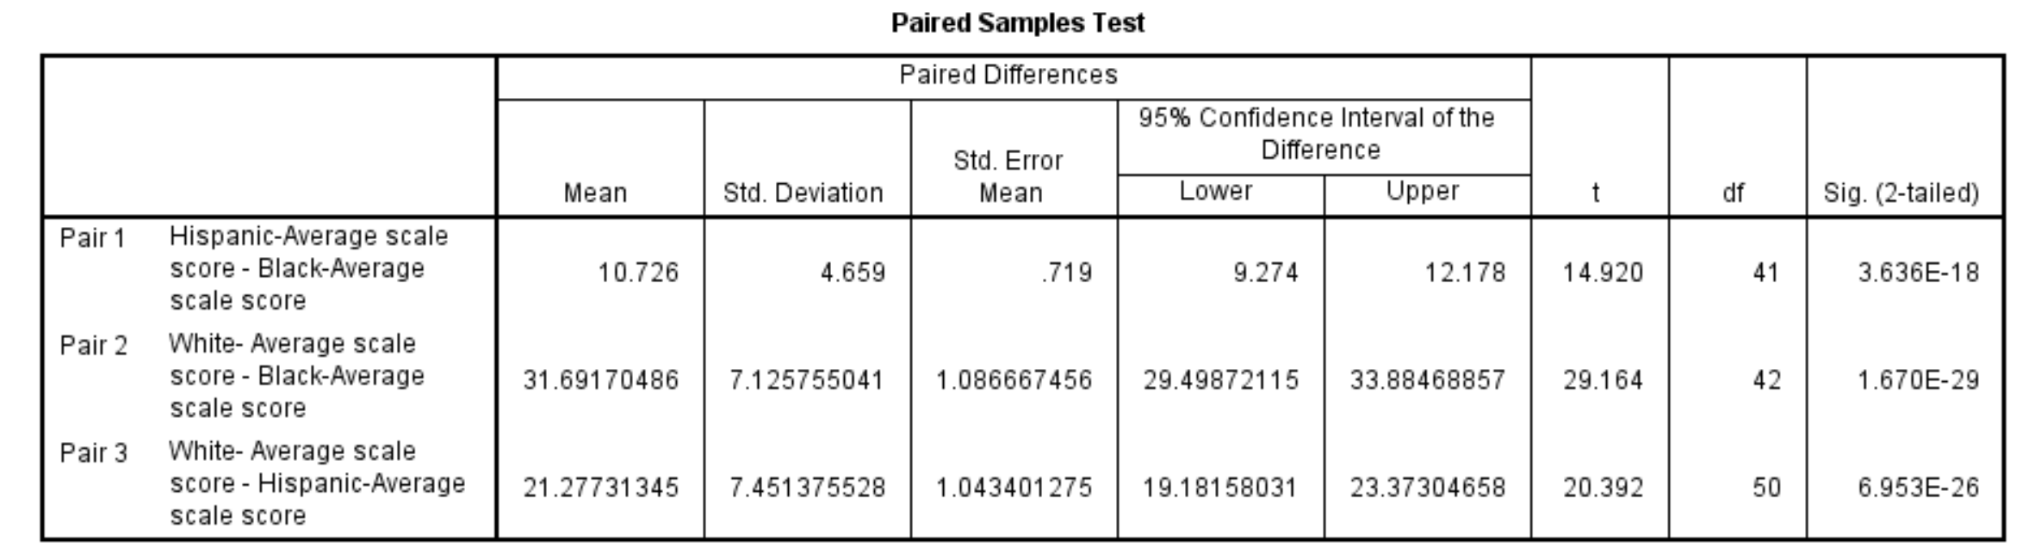
Table 6: Paired Samples Test.
Conclusion
Data analysis of the Paired Samples t-Test that was used to test the difference between the means of White Average Scale Score, Black Average Scale Score and Hispanic Average Scale Score concluded a statistical difference in average scores. The U.S. Department of Education and state level agencies will need to consider the results of this analysis to successfully plan for the next NAEP mathematics assessment by implementing programs that help minorities close the achievement gap in mathematics.

References
Brown, R. T. (2012). Educators' perspectives on closing the mathematics achievement gap in
fifth-grade mathematics classrooms (Order No. 3543944). Available from ProQuest Dissertations & Theses Global. (1220486490). Retrieved from https://search.proquest.com/docview/1220486490?accountid=12793
Hemphill, F. C., & Vanneman, A. (2011). Achievement Gaps: How Hispanic and White Students
in Public Schools Perform in Mathematics and Reading on the National Assessment of Educational Progress. Statistical Analysis Report. NCES 2011-459. National Center for Education Statistics.
International student assessment (PISA) - Mathematics performance (PISA) - OECD Data.
(n.d.). Retrieved April 23, 2017, from
https://data.oecd.org/pisa/mathematics-performance-pisa.htm
Kiersz, A. J. (2016, December 06). The latest ranking of top countries in math, reading, and
science is out - and the US didn't crack the top 10. Retrieved April 23, 2017, from http://www.businessinsider.com/pisa-worldwide-ranking-of-math-science-reading-skills-2016-12
Mathematics Literacy: Student Race and Ethnicity. (n.d.). Retrieved April 23, 2017, from
https://nces.ed.gov/surveys/pisa/pisa2015/pisa2015highlights_5e.asp
NAEP - 2015 Mathematics & Reading Assessments. (n.d.). Retrieved April 22, 2017, from
https://www.nationsreportcard.gov/reading_math_2015/#mathematics/state?grade=4
OECD (2017), Mathematics performance (PISA) (indicator). doi: 10.1787/04711c74-en
(Accessed on 23 April 2017)

