Girls In Technology 2017

Coding/ Decoding Using Binary Bracelets
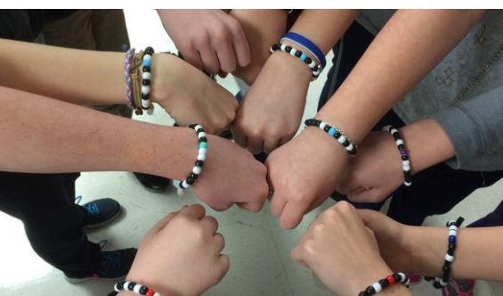

Objective:

Students will be able to code letters into binary, decode binary back to letters and relate to the process of coding/decoding data in a computer using beads to make bracelets.

Materials: (will be provided to us)

- Binary Decoder Key (200 copies)
https://code.org/curriculum/course2/14/Activity14-BinaryBracelets.pdf
- Black and white beads
- Separators (different color beads)
- Thread (pre-cut into 10 inches each)
- Pencils

Procedure:

- Introduce Binary (3 mins)

- Ask students if anyone knows what binary means.
- Ask students if they have ever seen what is inside a computer. Explain to students how wires inside a computer carry information in the form of electricity. Tell students that there are two options that computers use with respect to electrical information which is “off” and “on”.
- Give students definition of binary as a way of representing information using only two options such as “on” and “off”, “1” and “0”, “True” and “False”.
- Watch this video https://studio.code.org/s/course2/stage/14/puzzle/1
(we will not be able to show the video to students)
- Share with students that the word “bit” is short for “binary digit”.
- Ask if any student knows that grouping of eight bits is called a “Byte” and a grouping of four bits is called a “nibble”.

- Making the Binary Bracelets (19 mins)

- Transition to making the binary bracelets by explaining that the theme of two options will be used to make the bracelets.
- Explain that we will be using black and white beads where a black bead (no light) will represent “0” and a white bead (there is light) is “1”.
- The following binary decoder key will be used to make the bracelets:
https://code.org/curriculum/course2/14/Activity14-BinaryBracelets.pdf
- Ask students to find the initials of their first and last name on the binary decoder sheet
- Fill in the squares on the provided binary decoder using black and white beads to code the first letter of their first name.
- Students will use a different color bead as a separator between the two letters.
- Fill in the squares on the provide binary decoder using black and white beads to code the first letter of their last name.
- Use the provided thread to make the bracelets.
- Once the bracelets are made, tell students that they just learned how to code using binary code and now it is time to learn to decode.
- A secret word will be provided in a form of a binary bracelet/chain to each group (Fahima will make the bracelets/ chain).
- Students will be asked to decode the secret word. The group that decodes it first will win the competition for that session (make sure to write the school name).

3. Wrap up (3 mins)

- Ask students to tell you what they learned from this activity.
- Ask students to think about how else they might use binary code to design or represent something else.
- Ask what was their favorite part of this activity.
- Tell students that they get to keep and wear their bracelets.

Standards

ISTE Standards
- 1.a - Apply existing knowledge to generate new ideas, products, or processes.
- 1.c - Use models and simulation to explore complex systems and issues.
- 2.d - Contribute to project teams to solve problems.
- 4.b - Plan and manage activities to develop a solution or complete a project.
- 6.a - Understand and use technology systems.
- 6.d - Transfer current knowledge to learning of new technologies.

CSTA K-12 Computer Science Standards
- CT.L1:3-03. Understand how to arrange information into useful order without using a computer.
- CT.L1:6-03. Demonstrate how a string of bits can be used to represent alphanumeric information.
- CT.L1:3-05. Demonstrate how 0s and 1s can be used to represent information.
- CT.L2-07. Represent data in a variety of ways: text, sounds, pictures, numbers.
- CT.L2-08. Use visual representations of problem states, structures, and data.

NGSS Science and Engineering Practices
- K-2-PS3-2. Use tools and materials provided to design and build a device that solves a specific problem or a solution to a specific problem.
- K-2-ETS1-1 - Ask questions, make observations, and gather information about a situation people want to change to define a simple problem that can be solved through the development of a new or improved object or tool.

Common Core Mathematical Practices
- 1. Make sense of problems and persevere in solving them.
- 2. Reason abstractly and quantitatively.
- 4. Model with mathematics.
- 6. Attend to precision.
- 7. Look for and make use of structure.
- 8. Look for and express regularity in repeated reasoning.

Common Core Language Arts Standards
- SL.1.1 - Participate in collaborative conversations with diverse partners about grade 1 topics and texts with peers and adults in small and larger groups
- SL.1.2 - Ask and answer questions about key details in a text read aloud or information presented orally or through other media.
- L.1.6 - Use words and phrases acquired through conversations, reading and being read to, and responding to texts, including using frequently occurring conjunctions to signal simple relationships.
- SL.2.1 - Participate in collaborative conversations with diverse partners about grade 2 topics and texts with peers and adults in small and larger groups.
- SL.2.2 - Recount or describe key ideas or details from a text read aloud or information presented orally or through other media.
- L.2.6 - Use words and phrases acquired through conversations, reading and being read to, and responding to texts, including using adjectives and adverbs to describe.
- SL.3.1 - Engage effectively in a range of collaborative discussions (one-on-one, in groups, and teacher-led) with diverse partners on grade 3 topics and texts, building on others' ideas and expressing their own clearly.
- SL.3.3 - Ask and answer questions about information from a speaker, offering appropriate elaboration and detail.
- L.3.6 - Acquire and use accurately grade-appropriate conversational, general academic, and domain-specific words and phrases, including those that signal spatial and temporal relationships.

